**Keyword Driven Framework:**

The main advantage of keyword driven framework is, once this framework is created, even manual testers without any automation idea, can create the tests and run the tests without any problem.

Keyword Driven framework is a technique in which all the operations & instructions to be performed are written separately from the actual test case. For example, if we want to login to an application we perform the actions like opening the browser, entering the username, entering the password and clicking on login button.

We create a keyword sheet with these keywords and the corresponding actions will be written in a java file. Now whenever we have to login to the application we use these keywords and the corresponding class file which has the action methods to perform these actions and login into the application.

The following is an example of the keywords sheet.

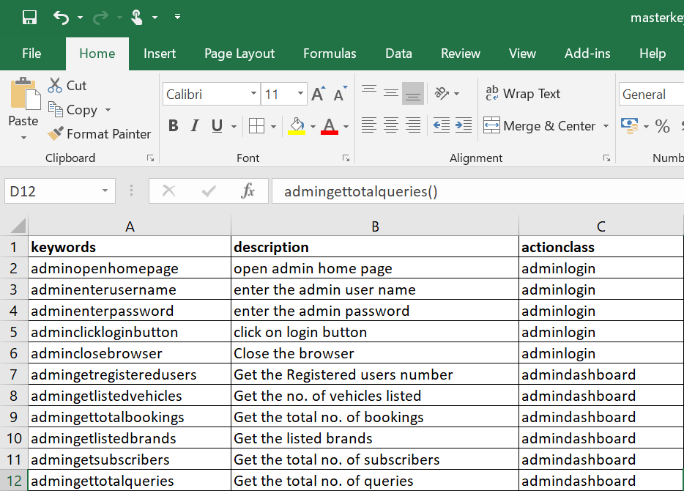

The actual test case will be an excel file like the following.

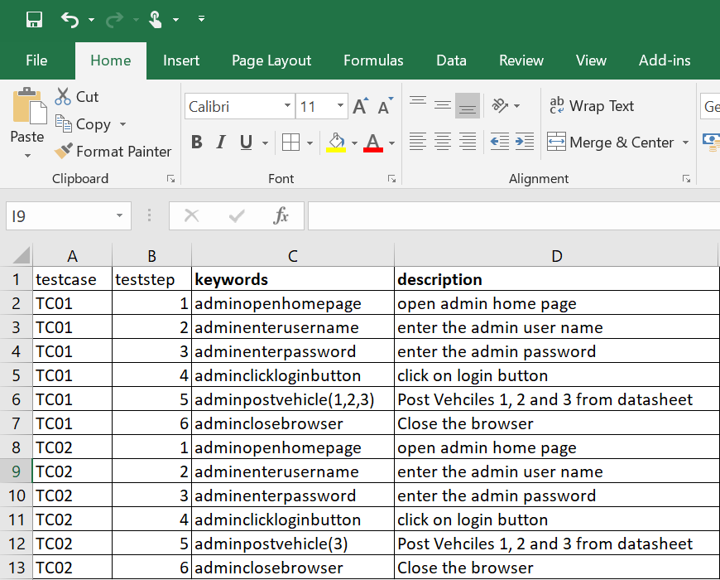

The above contains two test cases TC01 and TC02.

We maintain this test case information in a separate file like the following.

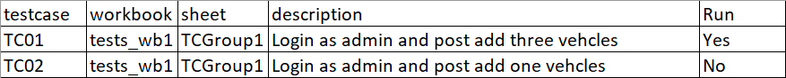

We can maintain the run mode as yes or no that means only the test cases with run mode as yes will be run during execution.

We write programs to read the keywords for each test case and perform the actions corresponding to the keyword.

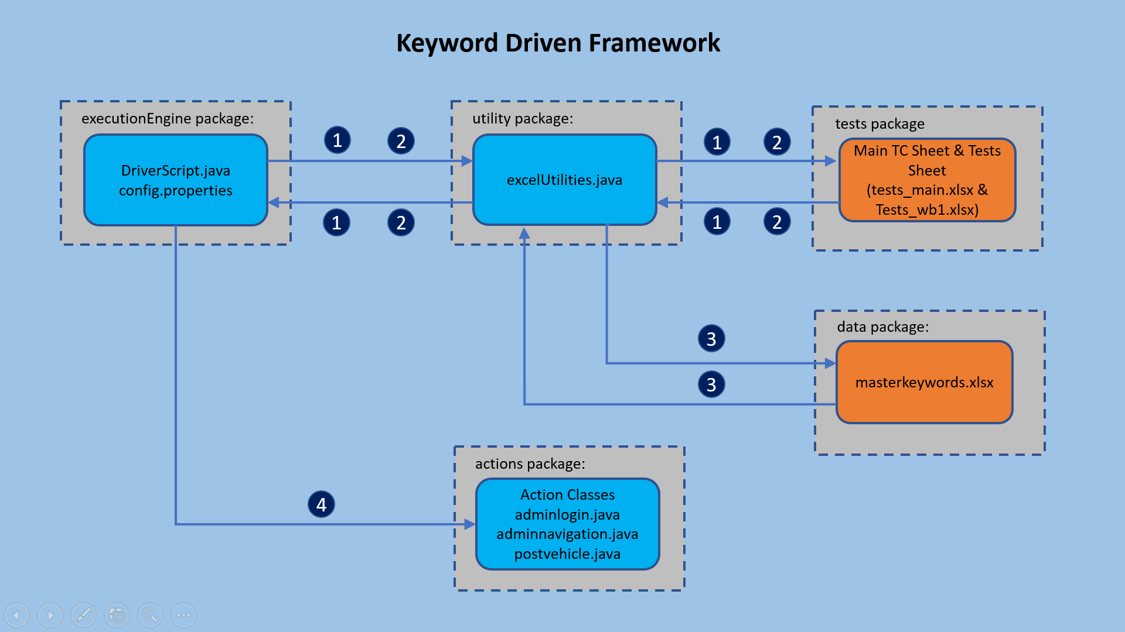

Once this framework is prepared, since it’s only creating an excel sheet with keywords, even manual testers can create these sheets and put them in framework.

Pros:

* In addition to advantages provided by Data Driven testing, the Keyword driven framework doesn’t require the user to possess scripting knowledge, unlike Data Driven Testing.
* A single keyword can be used across multiple test scripts.

Cons:

* The user should be well versed with the Keyword creation mechanism to be able to efficiently leverage the benefits provided by the framework.
* The framework becomes complicated gradually as it grows and a number of new keywords are introduced.